Innovative Machine Learning Approaches to Predict Soil CO₂ Emissions
Vincent Lu
BASIS Independent Fremont
Fremont California USA
Contact Email: funnymoose234@gmail.com

Abstract

Soil respiration represents the largest flux of carbon dioxide (CO₂) from the Earth's surface to the atmosphere. Despite its significance, accurately predicting CO₂ emissions from soil respiration remains a major challenge, and the effects of various environmental factors are not yet fully understood. This study leverages machine learning models to predict CO₂ emissions from soil respiration and evaluate the contributions of environmental drivers. An innovative ensemble model, XGBoost, is developed to estimate annual soil respiration (Rs) using spatial, temporal, climatic, and other independent variables. Additionally, a deep neural network (DNN) model is explored. The performance of these models is compared to two baseline approaches, Random Forest (RF) and Gradient Boosting (GB), used in previous studies. Among these, the XGBoost model achieves the best performance, showing a 4% reduction in MAE and RMSE and a 3.7% improvement in R² compared to the Random Forest model, previously identified as the top-performing method. However, the DNN model fails to produce reliable results, largely due to the limited sample size. For model explainability, SHAP (SHapley Additive exPlanations) is employed, providing insights into feature importance at both global and individual levels. The results highlight that Mean Annual Temperature (MAT) and Mean Annual Precipitation (MAP) are the most influential environmental factors, along with geographic variables such as latitude and longitude, consistent with prior research. Furthermore, Study Year, Soil Type, soil composition-related features, Elevation, and Basal Area (BA) are also identified as significant contributors to Rs estimates.

Keywords: Soil Respiration, Machine Learning, CO₂ emission, XGBoost Regressor, Model Explainability, SHapley Additive exPlanations, SHAP

1. Introduction
Soil respiration refers to the process by which carbon dioxide (CO₂) is released from the soil through the decomposition of organic matter by plant roots and microorganisms. It represents the largest CO₂ flux from the Earth’s surface to the atmosphere. Because the soil respiration rate is highly sensitive to environmental factors, accurately forecasting of CO₂ emissions from soil respiration is a significant challenge. Furthermore, the impact of various environmental factors on soil respiration is not yet fully understood.
Current approaches to address this problem can be grouped into two main categories. The first involves process-based models and the second approach employs statistical models. The process-based models explicitly model the biological and physical processes of soil respiration to simulate CO₂ emission and then incorporate variations to a regional scale. In contrast, statistical models, such as regression analyses, do not simulate the soil respiration process itself. Instead, they focus on extracting the relationships between soil respiration and environmental factors directly from data.
2. Related Work
2.1 Summary of Literature Review
Numerous studies have explored soil respiration estimation using process-based models. Lawrence et al [1] introduce the Community Land Model version 5.0 (CLM5.0), which simulates the interaction of land processes and atmospher, such as soil processes, vegetation dynameis, and river routing. To address the uncertainties in land-use carbon emission processes, Lienert & Joos [2] employ a Bayesian ensemble data assimilation approach to optimize model parameters and enhance stability and accuracy. Ito [3] demonstrates how disturbance-induced emissions and non-CO₂ carbon export flows impact terrestrial CO₂ budget imbalances in the process-based model, the Vegetation Integrative SImulator for Trace gases (VISIT). These models use a fundamental approach to simulate the soil respiration formation process, which is computationally intensive and time consuming, particularly for large scale estimation.
Alternatively, another line of research adopts a reduced-form approach, using statistical models to estimate soil respiration based on observable environmental factors, without modeling the complex processes underlying soil respiration. Adachi et al. [4] incorporate land-use changes derived from remote sensing data and climate variables into predictive models for soil respiration. Bahn et al. [5] investigate the relationship between mean annual soil temperature and annual CO₂ emissions from soil respiration through statistical analysis. Jian et al. [6] extend this work by incorporating both annual mean soil and air temperatures to predict annual CO₂ emissions. More recently, studies by Lu et al. [7] and Liu et al. [8] have introduced modern machine learning approaches, such as Random Forest models, to improve soil respiration predictions.
2.2 Research Gap
Most previous studies have relied on process-based approaches, which are computationally expensive and difficult to scale. With the public release of the Soil Respiration Database (SRDB), modern machine learning models present a viable alternative. Unlike traditional regression models, decision tree-based ensemble models, such as Random Forest and Gradient Boosting, do not make explicit assumptions about the relationships between dependent and independent variables. These models split the data at various thresholds of the independent variables, capturing the nonlinear relationships between them and the dependent variables. Ensemble models further enhance predictions by combining results from multiple trees, enabling them to capture complex nonlinearities. While some studies have explored this approach [4, 5], they mainly focus on traditional machine learning models like Random Forest and lack in-depth analysis of how different factors influence model outputs..
2.3 Objective of this Research
In this study, an innovative machine learning model, XGBoost, is developed to predict soil respiration. XGBoost model is an enhanced version of Gradient Boosting model and is widely used by researchers and practitioners due to its robust performance. In addition, a Deep Neural Networks (DNN) is explored. Unlike regression models that are inherently interpretable, both XGBoost and DNN models are considered as black boxes in explaining how the models make decisionsboth XGBoost and DNN are often regarded as black-box models, making it challenging to understand their decision-making processes. Common feature importance techniques provided by the XGBoost package, such as Weight, Cover, and Gain, often produce inconsistent results with slight variations in input data or model configurations. To address these limitations, the SHapley Additive exPlanations (SHAP) framework is utilized. SHAP, rooted in cooperative game theory, treats each input variable (feature) as a player and ensures fairness and consistency in attributing feature importance. The technique is used by previous studies [9] and [10] to provide model explainability of machine learning models. Moreover, SHAP provides insights into how individual factors influence model predictions, both at a global level and for specific instances. Consequently, SHAP is applied in this study to assess the impact of various features on model outcomes.

3. Methodology
3.1 Data
The data used in this study are sourced from the Soil Respiration Database Version 5 (SRDB-V5), a comprehensive global repository of published soil respiration research data (https://github.com/bpbond/srdb).
To ensure data quality, records flagged in the Quality_flag field are excluded. Additionally, data points with Rs_annual values exceeding 5000 gCm⁻² are removed, accounting for 22 records out of a total of 12,272 (less than 0.2%). Missing values in the independent variables were imputed using the median.
The dependent variable, Rs_annual, represents annual CO₂ emissions from soil respiration. Independent variables, referred to as features in machine learning terminology, are detailed in Table 1.
The dataset is split into 80% for training and 20% for testing to develop and evaluate the models.
Table 1: Summary of feature names and variable types
Category | Feature Names | Definition | Variable Type
Spatial/temporal | Study_year | Year study was performed (middle year if multiple years) | Numerical
 | YearsOfData | Years of data in the study | Numerical
 | Latitude | Latitude of the site | Numerical
 | Longitude | Longitude of the site | Numerical
 | Biome | Biome type | Categorical
 | Elevation | Elevation of the site | Numerical
Climate | MAT | Reported mean annual temperature | Numerical
 | MAP | Reported mean annual precipitation | Numerical
Land use | Ecosystem_type | Ecosystem type (grassland, forest, etc) | Categorical
 | Ecosystem_state | Ecosystem state (managed, unmanaged, natural) | Categorical
Soil | Soil_type | Soil description (classification and texture) | Categorical
 | Soil_drainage | Soil drainage (dry, wet) | Categorical
 | Soil_BD | Soil bulk density | Numerical
 | Soil_CN | Soil C:N ratio | Numerical
 | Soil_sand | Sand ratio | Numerical
 | Soil_silt | Silt ratio | Numerical
 | Soil_clay | Caly ratio | Numerical
Vegetation | Leaf_habit | Dominant leaf habit (deciduous, evergreen) | Categorical
 | Stage | Developmental stage (aggrading, mature) | Categorical
 | LAI | Leaf area index at site | Numerical
Carbon | BA | Basal area at site | Numerical
 | C_veg_total | Total carbon in vegetation at site | Numerical
 | C_AG | Total carbon in aboveground vegetation | Numerical
 | C_BG | Total carbon in belowground vegetation | Numerical
 | C_CR | Total carbon in coarse roots | Numerical
 | C_FR | Total carbon in fine roots | Numerical
 | C_soilmineral | Total carbon in soil organic matter | Numerical
 | C_soildepth | Depth to which soil C recorded | Numerical

3.2 Model Training
A new machine learning model, XGBoost, is introduced to estimate annual soil respiration (Rs). In addition, a deep neural network (DNN) is explored. Two baseline models from literature are evaluated on the same dataset for performance comparison.
Baseline models: Random Forest (RF) and Gradient Boosting (GB)
Previous research [4] and [5] demonstrate that Random Forest Models perform the best among all models.
XGBoost model
Unlike the generic Gradient Boosting (GB) model used in previous studies [5], XGBoost introduces significant enhancements, including effective regularization techniques, robust handling of missing values, parallelized training for faster computation, and optimized implementation. These features make XGBoost more accurate and efficient, making it a popular choice among industry practitioners.
Deep Neural Network (DNN)
The DNN model consists of an input layer, a normalization layer, two dense layers (44 neurons and 16 neurons, respectively, both using ReLU activation), and an output layer with a single neuron. The dense layers utilize the ReLU activation function due to its computational efficiency and ability to mitigate the vanishing gradient problem. The output layer, being part of a regression model, does not apply an activation function to ensure continuous output values.
Hyperparameter Optimization
There are various hyperparameters in ensemble models and it is infeasible to tune all parameters. Most important parameters from different groups, such as tree structure and boosting setting, are selected for optimization, covering the number of estimators, maximum tree depth, learning rate, and subsampling rate. The hyperparameter optimization function from Sklearn, GridSearchCV, combined with K-fold cross validation, is used to find the optimal input parameters in the models. For the DNN model, the number of neurons in the two dense layers and learning rate are also tuned.
Figure 1 illustrates the model training with hyperparameter optimization and model evaluation process.
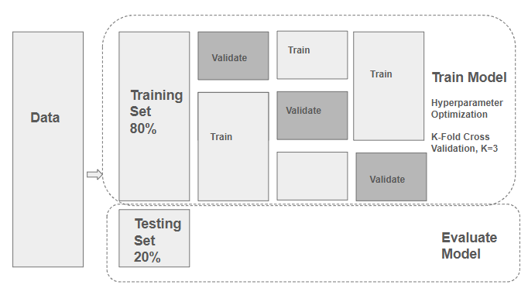
Figure 1. Model training and model evaluation workflow

3.3 Model Evaluation
Model performance evaluation is conducted on the testing dataset. The following three metrics are used to compare model performance.
Mean Absolute Error (MAE): Measures the average absolute errors between the predicted value and true value.
Root Mean Squared Error (RMSE): Represents the square root of the sum of the squared errors between the predicted value and true value.
Coefficient of Determination R² : Represents the proportion of the variance in the dependent variable (or response variable) that is explained by the independent variables (or features) in a regression model.
4. Result and Discussion
4.1 Model Performance
The results of the three models are summarized in the table below.

Table 2: Summary of model performance and comparison

Evaluation metrics | RF | GB | XGBoost | DNN
MAE | 186.97 | 206.63 | 179.43 | 331.08
RMSE | 311.43 | 324.87 | 297.90 | 500.71
R² | 0.700 | 0.673 | 0.726 | 0.225

As shown in table 2, the XGBoost model outperforms the other three models, achieving the highest R², lowest MAE, and lowest RMSE. The XGBoost model achieves 4% reduction in MAE and RMSE and 3.7% increase in R² compared to the Random Forest model which demonstrates the best performance in previous work in [7] and [8].

The DNN model performs poorly compared to other models, likely due to the small size of the datasets. The plot below illustrates overfitting in the DNN model: as the number of epochs increases, the loss on the training set continues to decrease, while the loss on the evaluation set levels off.

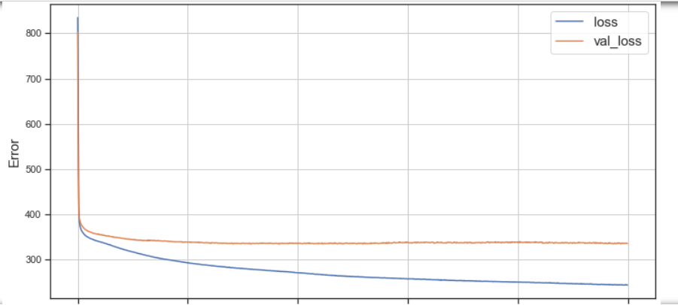
Figure 2. Loss function vs numer of epochs in training and validation set

4.2 Model explainability with SHAP analysis
A common critique of machine learning models is their lack of interpretability. Unlike statistical models, which are inherently interpretable, machine learning models are frequently viewed as a "black box." Shapley Additive Explanations (SHAP) is a methodology used to address this limitation. It quantifies the impact of input features on model predictions, both globally and for individual outcomes. SHAP has been successfully applied in many fields, for example [9] and [10]. In this study, SHAP is applied to the XGBoost model to investigate feature importance, feature dispersion, partial dependence, and interactions between different features.
4.2.1 Global feature importance, density, and dispersion
The average impact of different features on model predictions is shown in Figure 3.A. Latitude emerges as the most influential feature, followed by Mean Annual Precipitation (MAP), Longitude, Study Year, and Mean Annual Temperature (MAT). Soil-related features, Elevation, and Basal Area (BA) also rank within the top 10 most influential features. These findings align with previous results reported in [8], where MAP and MAT are also identified as key factors alongside geographical features such as longitude and latitude. A notable difference, however, is the ranking of Elevation, which appears at number 9 in this study compared to the top 5 in [8]. This discrepancy may be attributed to missing values in the elevation data.

In addition to global feature importance, SHAP analysis also reveals the impact of features on individual predictions. Figure 3.B presents a distribution plot that illustrates how features contribute to the predicted value for each data point. The shade of each dot represents the feature value, and the x-axis indicates the predicted value. The plot shows that lower latitudes are associated with higher Rs values, while higher MAP and MAT values also correlate with higher Rs values.

A | 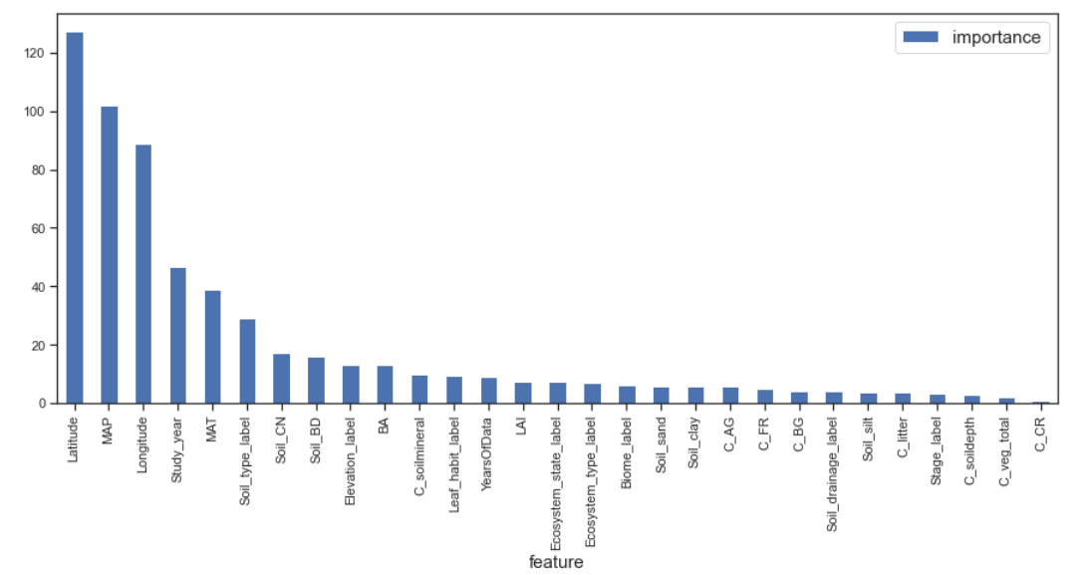
B | 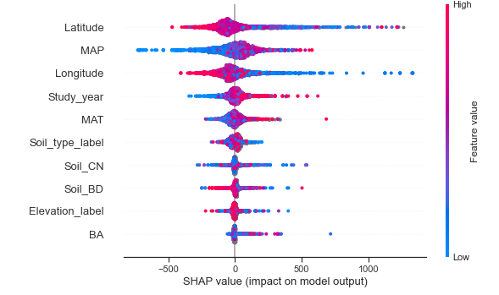

Figure 3: A) Diagram of feature importance; and B) Feature dispersion - XGBoost Model

4.2.2 Partial Dependency and interaction effect
Partial dependence plots from SHAP illustrate how the model outcome changes as a specific feature changes, while other features remain unchanged. It is a robust way to examine the relationship between input features and model predictions. Partial dependence plots can also show how two features interact with each other.
Figure 4.A shows the predicted Rs values for different MAP values across all observations in the dataset, assuming other features remain unchanged. As MAP increases up to 1000 mm, Rs increases. However, beyond 1000 mm of MAP, the predicted Rs values level off. Figure 4.B displays a slight upward trend between MAT and Rs. Figure 4.C illustrates that when both MAT and MAP are low, predicted Rs values are also low. High MAT and MAP lead to higher Rs. However, when MAT is moderate, the positive correlation between MAP and predicted Rs becomes less pronounced.
Figure 5.A shows a clear upward trend between study year and predicted Rs, indicating higher Rs in recent years. Figure 5.B illustrates the relationship between Leaf Area Index (LAI) and Rs. LAI is an index that measures leaf coverage at a site; a higher LAI value signifies a denser canopy with more leaves per unit of ground area. The figure shows that as LAI increases, Rs also increases.

A | 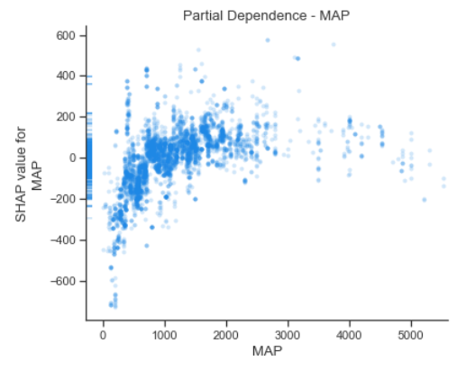 | C | 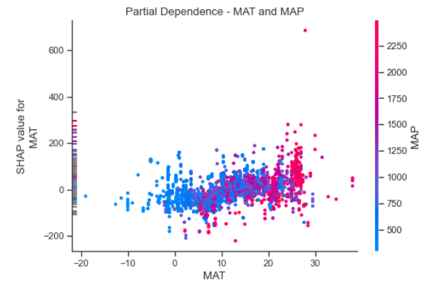
B | 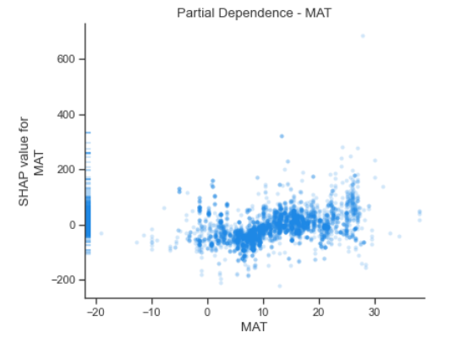
Figure 4: A) Partial dependence with respect to MAP; B) with respect to MAT; and C) interaction between MAT and MAP.

A | 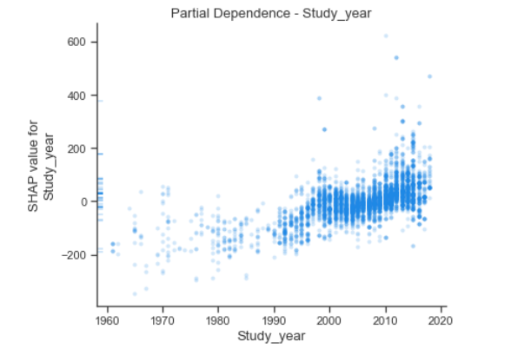 | B | 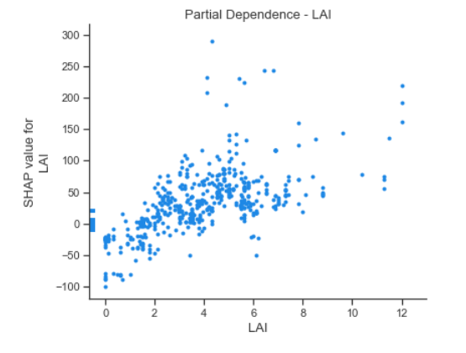

Figure 5: A) Partial dependence with respect to study year; B) with respect to LAI

4.2.3 Force plot
SHAP force plot visualizes how different features influence the model prediction for a specific observation. The features driving the prediction higher are in red and the features decreasing the predicted value are in blue. Figure 6 shows the top features in driving Rs higher for this observation are Longitude, Soil_sand, Soil_silt. However, Latitude, MAP, LAI and Study Year, impact the results negatively.
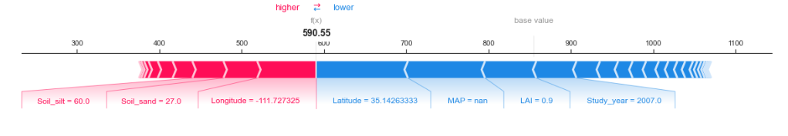
Figure 6. Force plot of a specific prediction
4.3 Model comparison
Two models in forecasting soil respiration are developed: XGBoost and Deep Neural Network. Random Forest model and Gradient Boosting model are used as baseline models for performance comparison.
The XGBoost model yields best performance with lowest MAE, MRSE and highest R². It outperforms the Random Forest model that is suggested in current literature [7, 8]. The DNN model is not able to achieve good results, primarily due to limited data.
Unlike the Random Forest model and the DNN model, the XGBoost model handles missing values internally and does not require imputations. This feature makes the XGBoost model more robust to missing values.
The Rs_annual values in the datasets include extremely large values. About 99.8% of records are below 5000 gCm⁻² and only 22 records are above the threshold. After excluding the extremely large Rs_annual values, both the performance of the XGBoost model and the performance of the Random Forest model increases by ~10% in R².
The DNN model is extremely sensitive to outliers. Therefore, a normalization layer is added after the input layer in the model. In contrast, both the XGBoost model and the Random Forest model are less sensitive and do not require normalization.
Lastly, the DNN indicates difficulty in yielding comparable results with other models even after tuning the hyper parameters in model configuration, primarily due to limited data and missing values in some features. This suggests exploring other data sources for future enhancement.
4.4 Model limitations
This study has several limitations. First, the sample size is relatively small. The original dataset contains 12,272 observations, but only 6,379 remain after removing data with quality issues and outliers. Second, many vegetation and carbon-related features have missing values, which may impact model performance. Third, the database is compiled from published studies, and its coverage is therefore limited.
5. Conclusion
In this work, an innovative ensemble model, XGBoost, is developed to predict annual Rs from spatial, temporal, climate, and other independent variables. In addition, a DNN model is experimented. The models are evaluated against two baseline models, Random Forest (RF) and Gradient Boosting (GB), which are established as benchmarks in previous studies [7] and [8].
The XGBoost model delivers the best performance, achieving a 4% reduction in MAE and RMSE and a 3.7% improvement in R² compared to the Random Forest model, previously identified as the top-performing approach. However, the DNN model fails to achieve reasonable results, primarily due to the limited sample size.
SHAP (SHapley Additive exPlanations) is employed as a robust method for model explainability, enabling the assessment of feature impacts on predictions both globally and at the individual observation level. Results reveal that Mean Annual Temperature (MAT) and Mean Annual Precipitation (MAP) are the most influential environmental factors, alongside geographic features such as latitude and longitude, aligning with previous studies. In addition the four features, Study Year, Soil Type, soil composition related features, Elevation, and Basal Area (BA) also demonstrate high impact on Rs estimates.
A notable challenge in this study is the significant amount of missing data for vegetation and carbon-related features. Median imputation is applied to address this issue. As a next step, further exploration of alternative data repositories, such as ERA5, is planned to improve data quality and model performance. Another challenge is the small sample size, especially after excluding records with quality issues. Identifying reliable data sources and addressing data quality issues will be critical areas of focus to improve model robustness and performance.
References

[1] D. M. Lawrence et al., "The Community Land Model version 5: Description of new features, benchmarking, and impact of forcing uncertainty," J. Adv. Model. Earth Syst., vol. 11, no. 12, pp. 4245–4287, 2019.
[2] S. Lienert and F. Joos, "A Bayesian ensemble data assimilation to constrain model parameters and land-use carbon emissions," Biogeosciences, vol. 15, no. 9, pp. 2909–2930, 2018.
[3] A. Ito, "Disequilibrium of terrestrial ecosystem CO₂ budget caused by disturbance-induced emissions and non-CO₂ carbon export flows: A global model assessment," Earth Syst. Dyn., vol. 10, no. 4, pp. 685–709, 2019.
[4] M. Adachi et al., "Estimation of global soil respiration by accounting for land-use changes derived from remote sensing data," J. Environ. Manag., vol. 200, pp. 97–104, 2017.
[5] M. Bahn et al., "Soil respiration at mean annual temperature predicts annual total across vegetation types and biomes," Biogeosciences, vol. 7, no. 7, pp. 2147–2157, Jul. 2010. doi: 10.5194/bg-7-2147-2010.
[6] J. Jian et al., "Prediction of annual soil respiration from its flux at mean annual temperature," Agric. For. Meteorol., vol. 287, 107961, 2020.
[7] J. Liu, J. Hu, H. Liu, et al., "Global soil respiration estimation based on ecological big data and machine learning model," Sci. Rep., vol. 14, 13231, 2024. doi: 10.1038/s41598-024-64235-w.
[8] H. Lu, S. Li, M. Ma, et al., "Comparing machine learning-derived global estimates of soil respiration and its components with those from terrestrial ecosystem models," Environ. Res. Lett., vol. 16, no. 5, Art. 054048, 2021. doi: 10.1088/1748-9326/abf526.
[9] E. Strumbelj and I. Kononenko, "An efficient explanation of individual classifications using game theory," J. Machine Learning Res., vol. 11, pp. 1–18, 2010.
[10] H. Luo, C. Xiang, L. Zeng, et al., "SHAP-based predictive modeling for 1-year all-cause readmission risk in elderly heart failure patients: Feature selection and model interpretation," Sci. Rep., vol. 14, 17728, 2024. doi: 10.1038/s41598-024-67844-7.

